1

On 21 September, Toulouse was struck by a disaster on an unprecedented scale, in which 29 people died and 2500 were injured. We have all been concerned and deeply saddened by the suffering of the victims families, of the injured and by the grief of the people of Toulouse. Following the explosion at the AZF factory, I sent a message on behalf of Parliament, and on my own behalf, to the Mayor of Toulouse, Mr Douste Blazy and to his fellow citizens, to express our solidarity and the deepest sympathy. The exact causes of this awful disaster are still unknown.

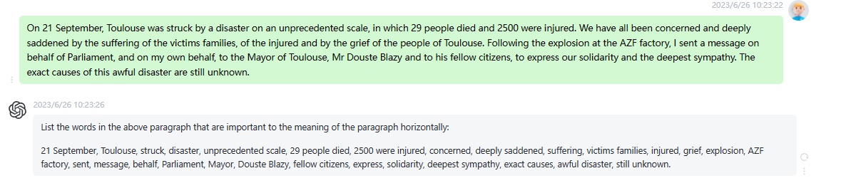

时延0.2s

2

In a repeat of previous incidents, this time in Northern Ireland, a journalist, Martin Hagan, was murdered on European Union soil by terrorists with a single objective to spread fear by firstly attacking those who work to inform others. This appalling act is an attack by its perpetrators on the fundamental values of the European Union, namely the right to life, the rule of law and the freedom of expression. Under no circumstances must these acts of terrorism call into question the efforts of all those who, in spite of the difficulties they encounter, are working tirelessly to finally achieve

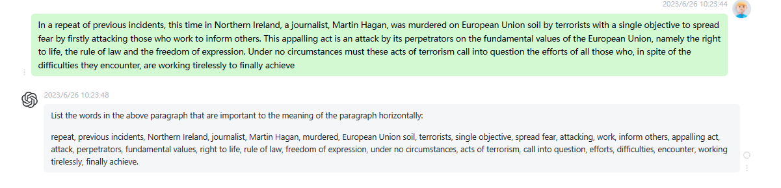

时延0.2s

3

I want to say this because I wish to express my solidarity and that of my group with the statements by the President of the Commission, Mr Prodi, the Vice President of the Commission, Mr Patten, the President in Office of the Council, Mr Michel, the President of the French Republic, Mr Chirac, and in this case I regret that we have not heard him speak since he always does so authoritatively, bravely and appropriately in relation to the unfortunate public remarks of the President of the Council of Ministers of the Republic of Italy, Mr Berlusconi, on the supposed

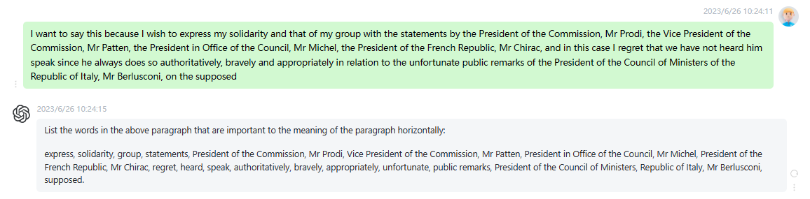

时延0.2s

4

I believe it is especially important now for the European Parliament to state strongly once again, that this is not a clash of civilisations, but, rather, that we have to defend values that are shared by all humanity. I therefore believe it is important that we, in the European Parliament, clearly express and demonstrate an approach, which is not just the approach of my group, and in this case I would like to address Mr Poettering to say that I was the first to applaud when, at the special sitting we held on the attacks of 11 September, he expressly

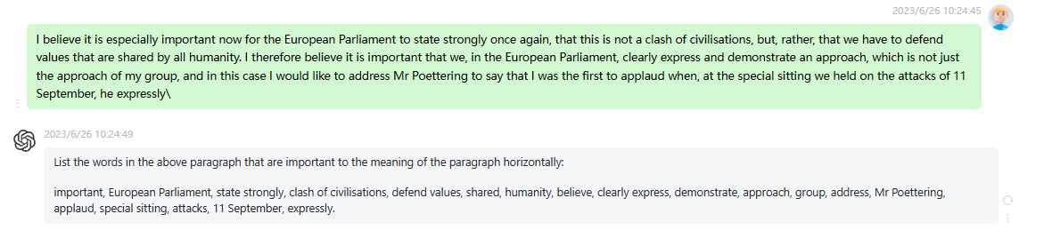

时延0.2s

5

On the other hand, we recall Mr Solan words, spoken in the same spirit, who had advised and I quote that we must not create a rift, as this would be a huge mistake. Mr Berlusconi astounding and deeply shameful words show how important it is to issue a very clear response. First of all, we must strongly condemn the age old rumour of the purported superiority of Western civilisation and Christianity. Then, we must decide upon an initiative, along the lines of Article 7 of the Treaty of Nice, enabling the Council to determine that there is a clear

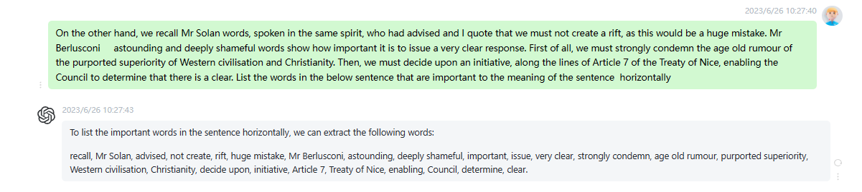

时延0.15s

6

I refer back to Anwar el Sadat tremendous speech to the European Parliament on 10 February 1981 we were meeting in Luxembourg in those daysin which he said, Islam is a religion of love and not of hate. On behalf of our group, I wish again to observe that we oppose the rhetoric which speaks of a clash of civilisations and that we desire partnership and friendship with all peace loving Arab and Islamic countries. It is precisely for that reason, indeed, that I proposed that we should convene the Mediterranean Forum. I am given to understand, Madam President, that

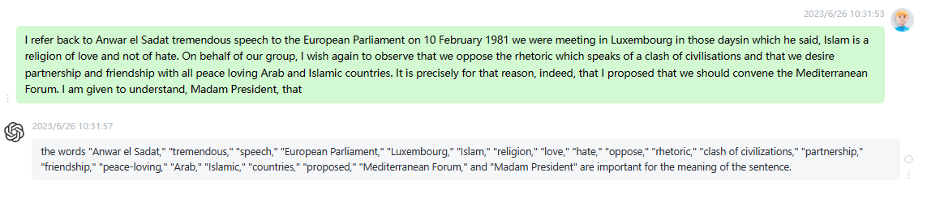

时延0.2s

7

Having been addressed personally, I wish to point out certain misunderstandings which originate with a Member of the Commission. We agreed in the Conference of Presidents Mr Baron Crespo was unable to be there last Thursday that we do not want to make this the subject of the debate here in the plenary sitting but wish, rather, in the Conference of Presidents on Thursday, to consult with the Member of the Commission about the remarks that have been made. On behalf of our group, let me say here and now that we reach out our hands to all peace loving

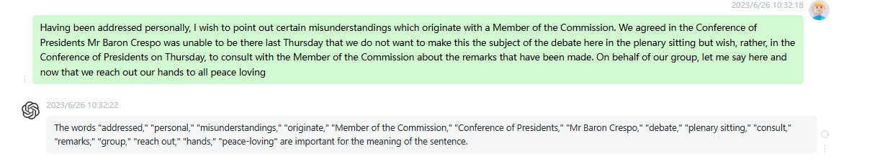

时延0.2s

8

It is an unfortunate fact of our life in this world today that many hundreds of journalists die virtually every year in pursuit of their vocation of serving and informing the public. This does not happen so often in democratic societies and it is particularly worrying, therefore, that journalists in Northern Ireland are at risk in this way. The few words I have said about Martin Hagan are entirely inadequate to convey the shock and the horror that people of all political and religious persuasions in Ireland feel at this horrible deed. I should like to link this with other

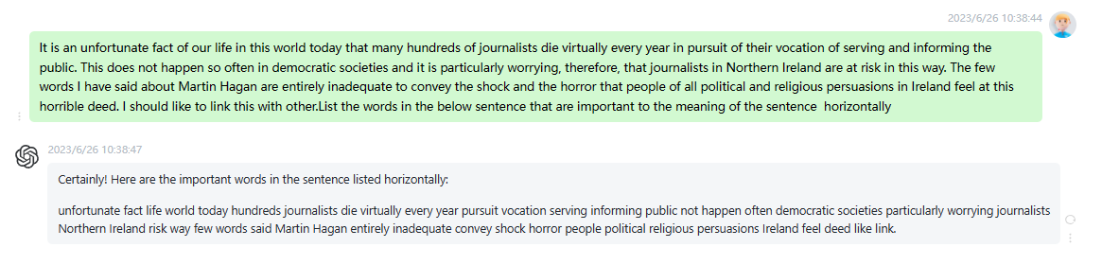

时延0.15s

9

Madam President, you have always strongly advocated dialogue with Islam, and have also taken definite steps in the direction of such dialogue. Your policy stands in contradiction to what Mr Berlusconi has said. In view of the fact that you have had very forthright things to say in other situations which I did not always find easy to defend back home, but I defended you because I have always valued your clear language I think it important that you should find equally clear and unambiguous words in this connection. It is this that I ask of you. Perhaps these words

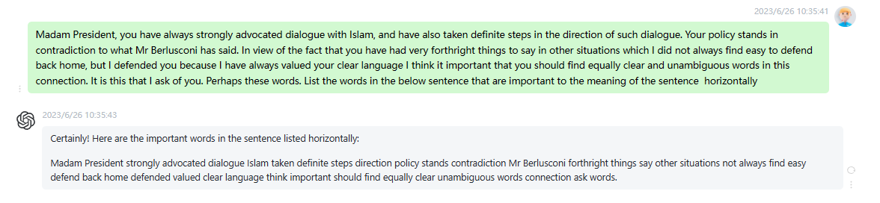

时延0.1s

10

Moreover, the Italian Prime Minister, Mr Berlusconi, has provided ample explanation of what he meant by the statement, which he intended to be extremely positive. The difference between the two civilisations is clear, and his intention was merely to highlight and emphasise that there is a great difference as regards genuine freedom, which exists in the West but not in the East, as regards equal opportunities for men and women, which are established in the West but denied in the East, and as regards all those differences in civilisation which it cannot be denied are there. That was what Mr

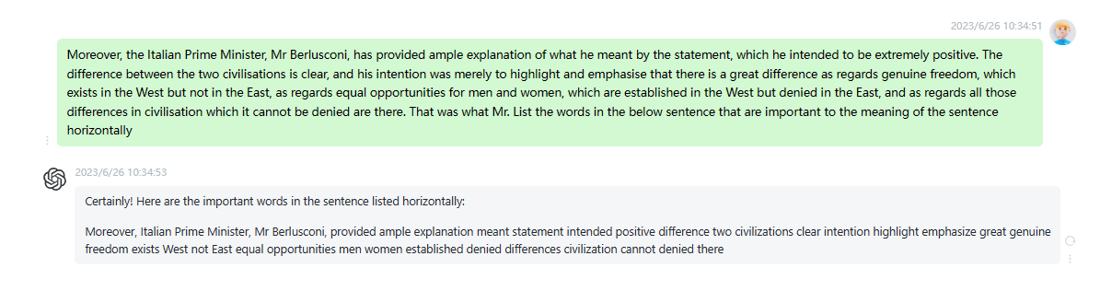

时延0.1s